# ABC’s Inventory Management System

## Test Script

|  |  |  |  |  |  |
| --- | --- | --- | --- | --- | --- |
| **Test Name** | | Send Duplicate Product To The Destination (Test Case SPT001) | | | |
| **Use Case Tested** | | Send Product | | | |
| **Test Description** | | This test tests if the system can send duplicate product items and its normal quantity in current location to destination location. | | | |
| **Pre-Conditions** | | Meta data must exist, product and product details like product item code, location ID and product quantity. | | | |
| **Post-Conditions** | | Sending Products should be sent to the destination, the status of transfer change to “Sending” to wait for the receiver accept it, the quantity of sending product from sending location should be reduced. Appropriate Alert message is displayed for the duplicate product when adding to the cart table. | | | |
| **Notes** | | This test assumes that the user knows the destination name, product item code. | | | |
| **Result (Pass/Fail/Warning/ Incomplete)** | | Pass | | | |
|  | **Test Step** | | **Expected Test Results** | **P** | **F** |
| 1. | Select Send Product Button from home page | | Display the Send Product page |  |  |
| 2. | Select the destination location | | Destination location combo box changes to the selected location name | P |  |
| 3. | Enter the description for this transfer | | Description text area displays user inputs | P |  |
| 4. | Select the product item code in the table on the left | | System waits for hitting the “Add to Cart” Button | P |  |
| 5. | Click on the “Add To Cart” Button | | The selected item displayed in the right table (cart table) with default quantity is 1 | P |  |
| 6. | Double click to the quantity cell in selected cart table | | System change the cell of double clicked cell to be editable | P |  |
| 7. | Enter the desirable number | | System waits for hitting enter key from user. | P |  |
| 8. | Hit enter key to confirm this edited quantity | | System waits for adding other product items and hitting the “Send Product” Button | P |  |
| 9. | Select the same product item code which is added to the cart and add to the cart again | | System displays an alert message to notify that user cannot add this product to the cart again. | P |  |
| 10. | After added the desirable items, hit the “Send Product” Button | | An message pops up to notify that the products in the cart table are sent to the destination.  Reset the interface for working with new transfer. | P |  |

## Data Set 1

|  |  |  |
| --- | --- | --- |
| **Test Data Table** | | |
| **Destination Location** | Oxford Store | |
| **Description** | Send Product From Warehouse to Oxford Store | |
| **Product Item Code** | Z2100 | Z2100 |
| **Quantity** | 2 | N/a |

# Result Screenshots

The screenshots of the result on each test step for each data set are given below:

**Step 1**

Select the destination location

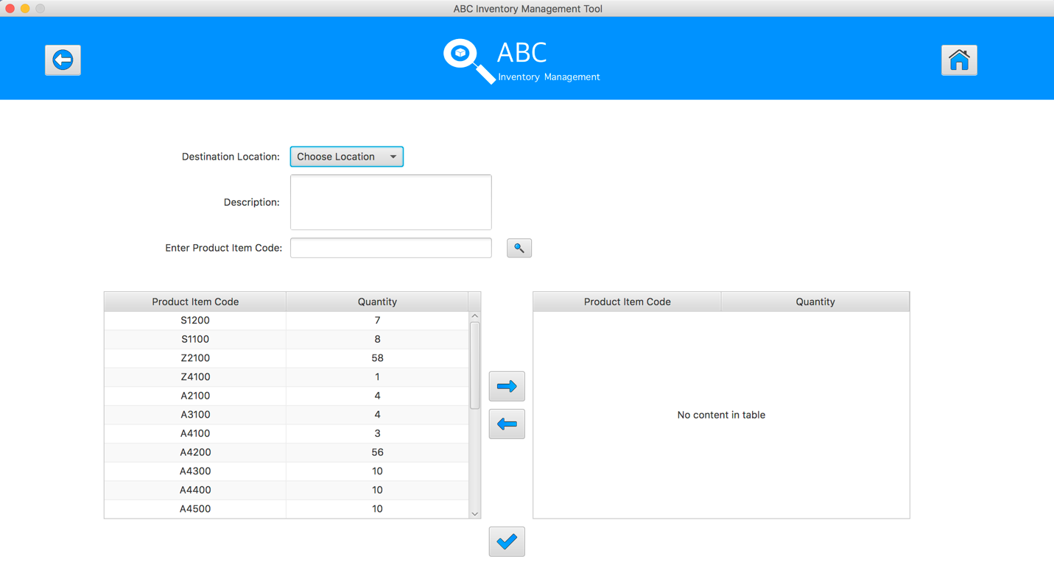

**Step 2**

Enter the description for this transfer

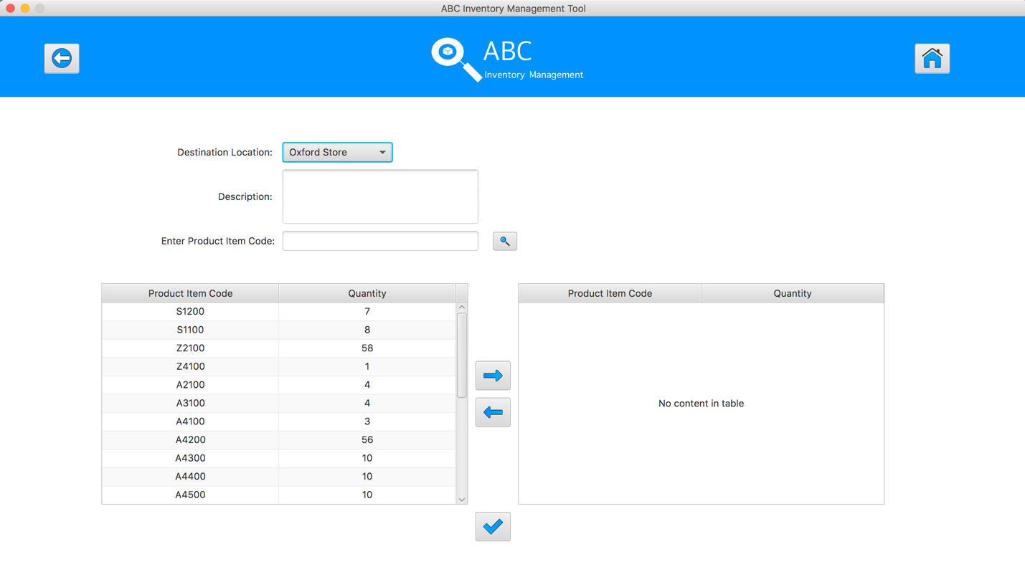

**Step 3**

Select the product item code in the table on the left

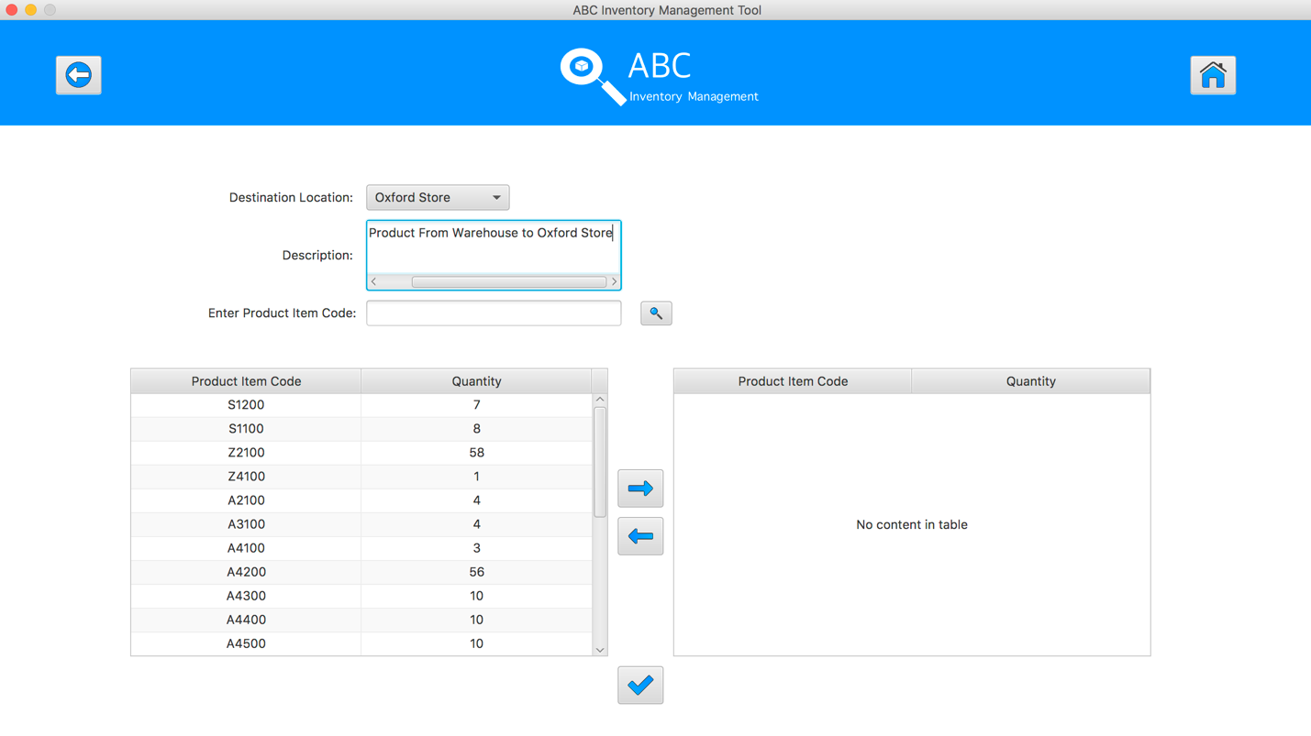

**Step 4**

Select the product item code in the table on the left

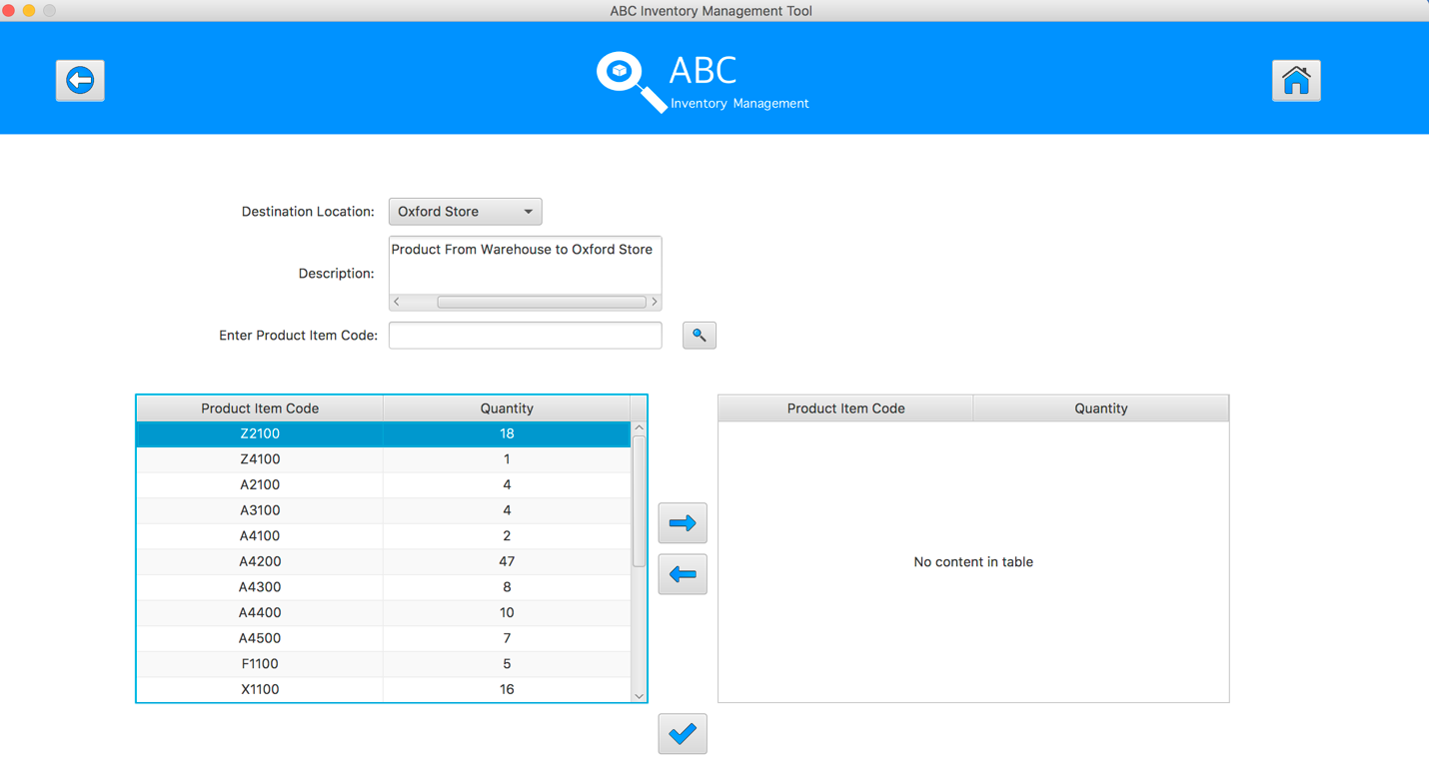

**Step 5**

Click on the “Add To Cart” Button

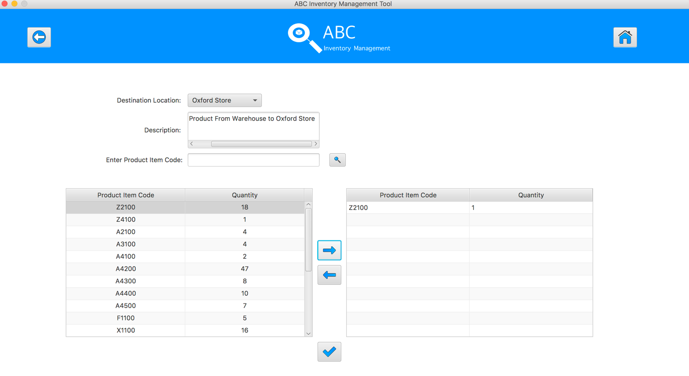

**Step 6**

Double click to the quantity cell in selected cart table

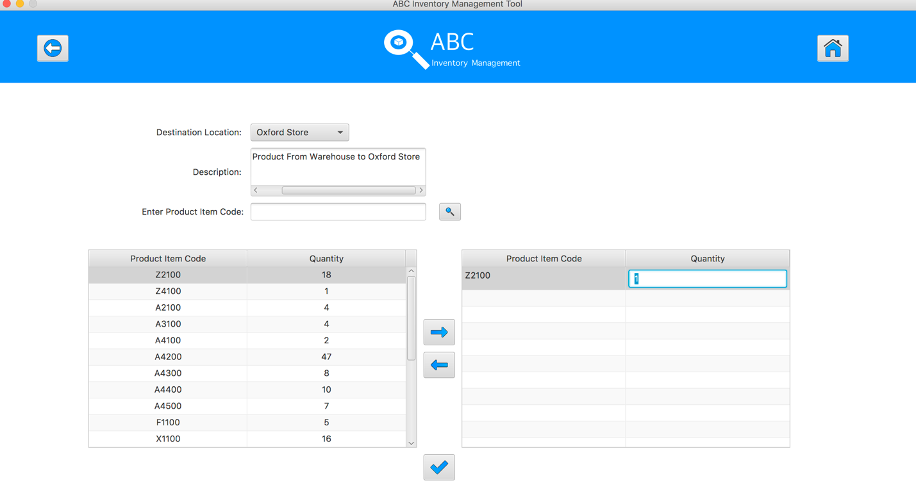

**Step 7**

Enter the desirable number

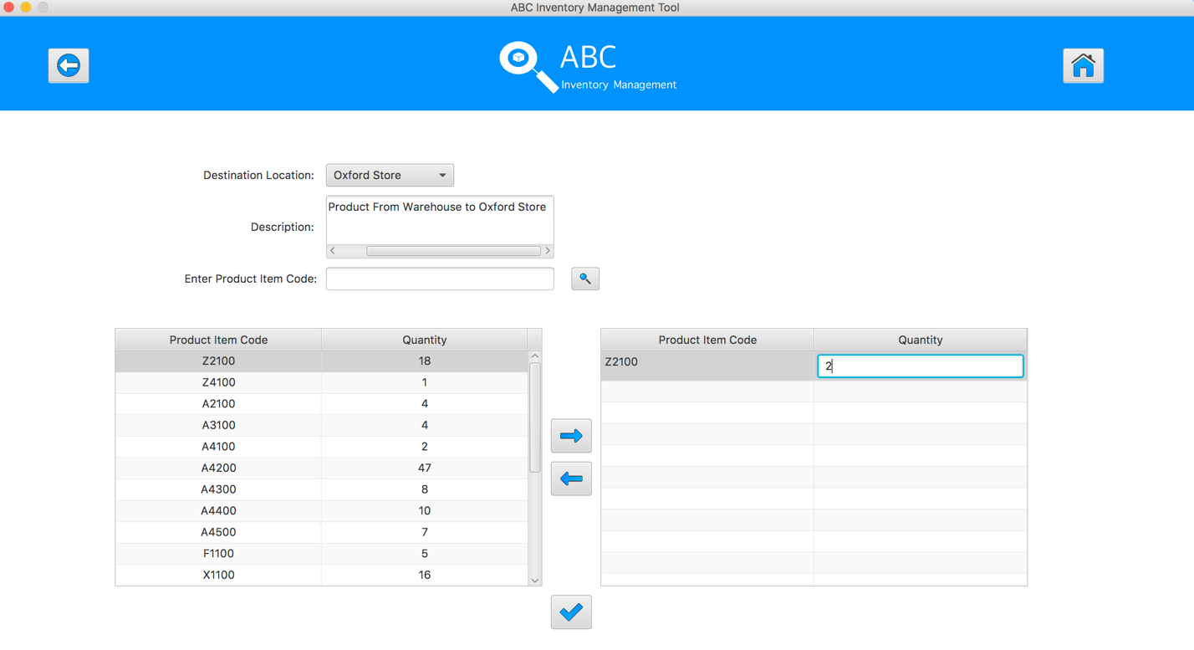

**Step 8**

Hit enter key to confirm this edited quantity

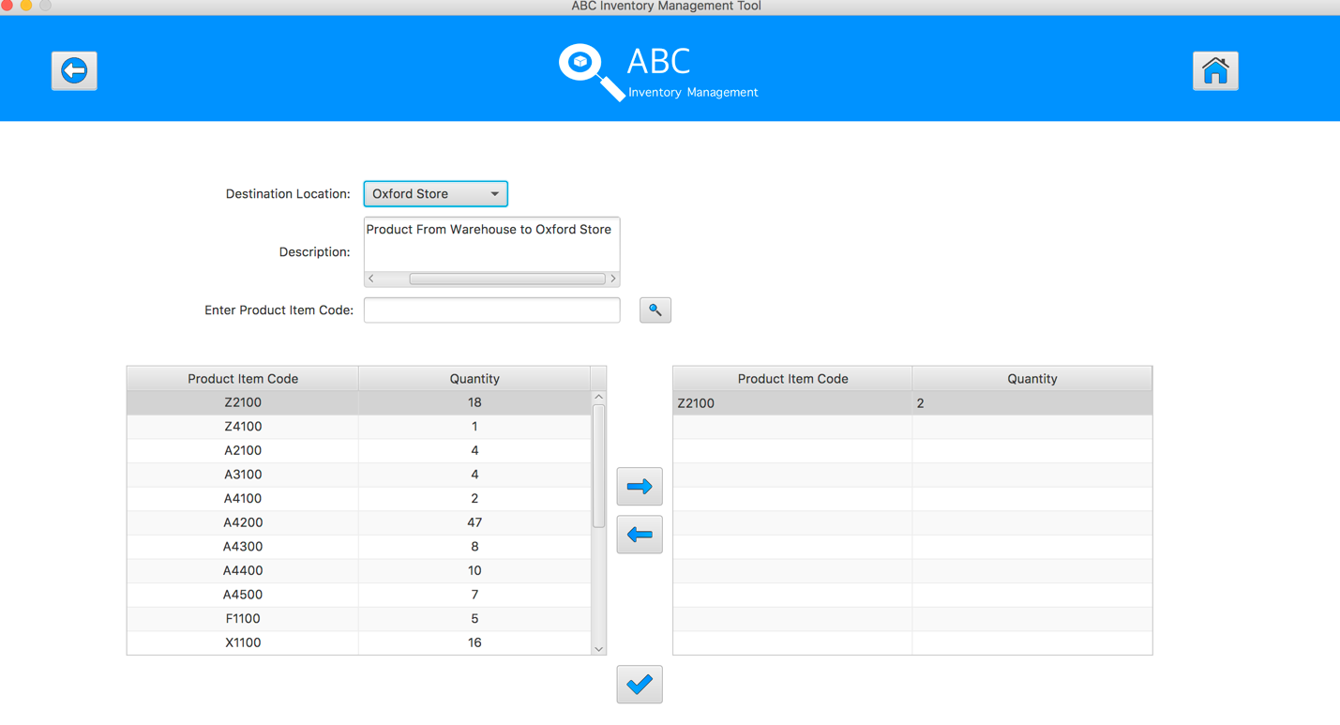

**Step 9**

Select the same product item code which was added to cart table in the table on the left

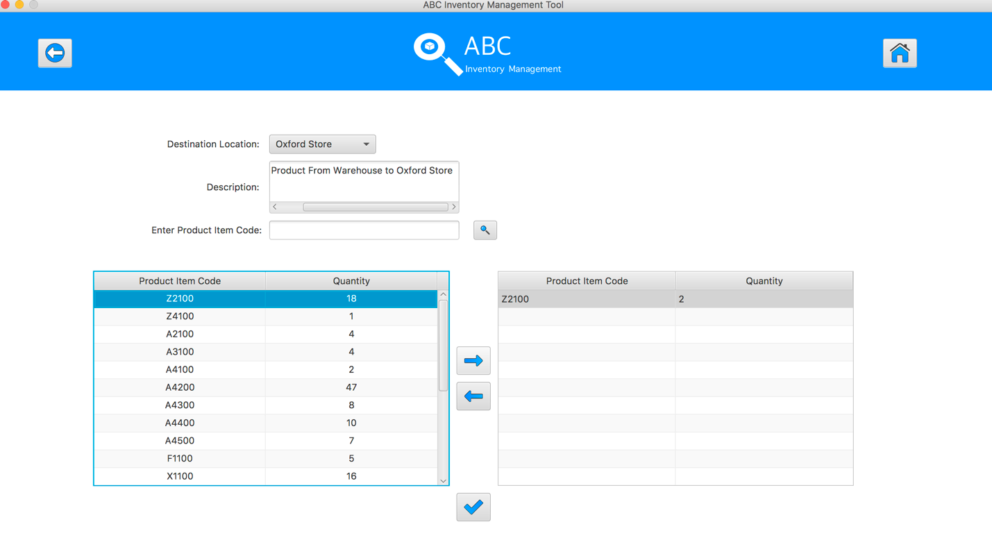

**Step 10**

System displays an alert message to notify that user cannot add this product to the cart again.

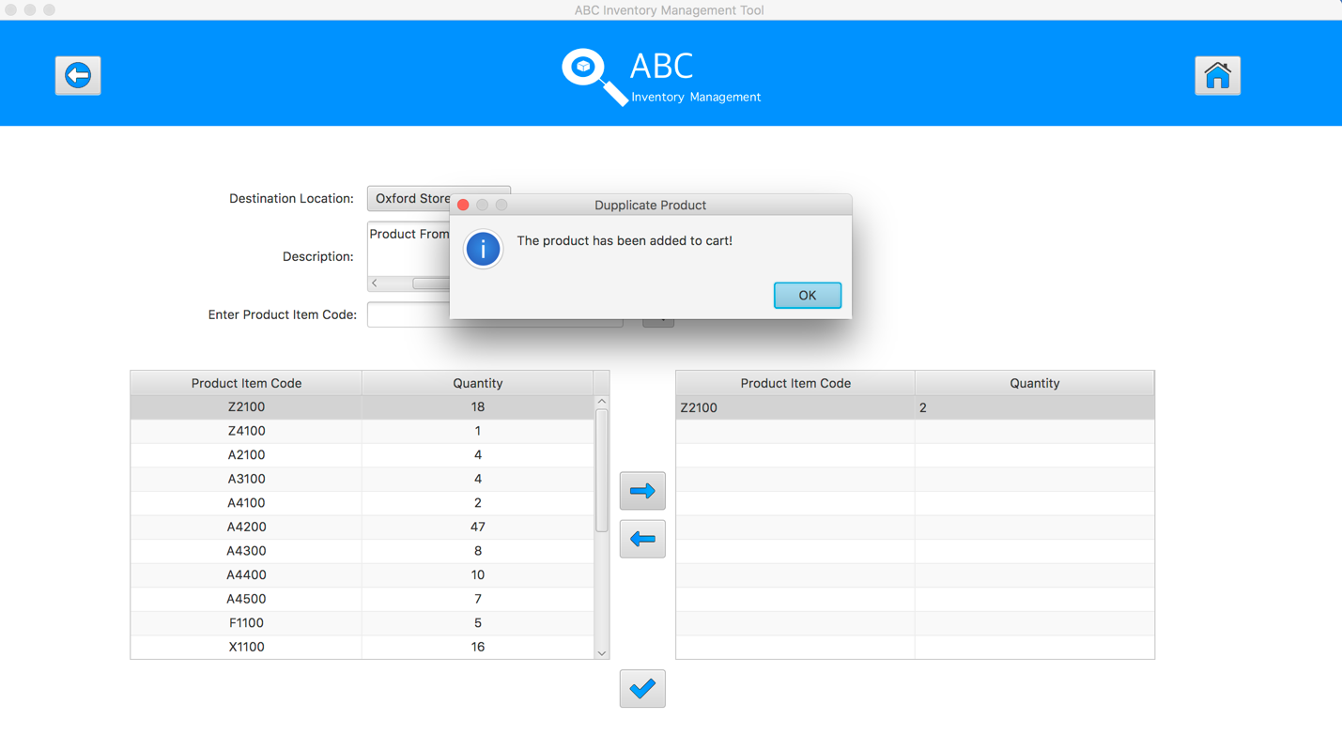

**Step 11**

After added the desirable items, hit the “Send Product” Button 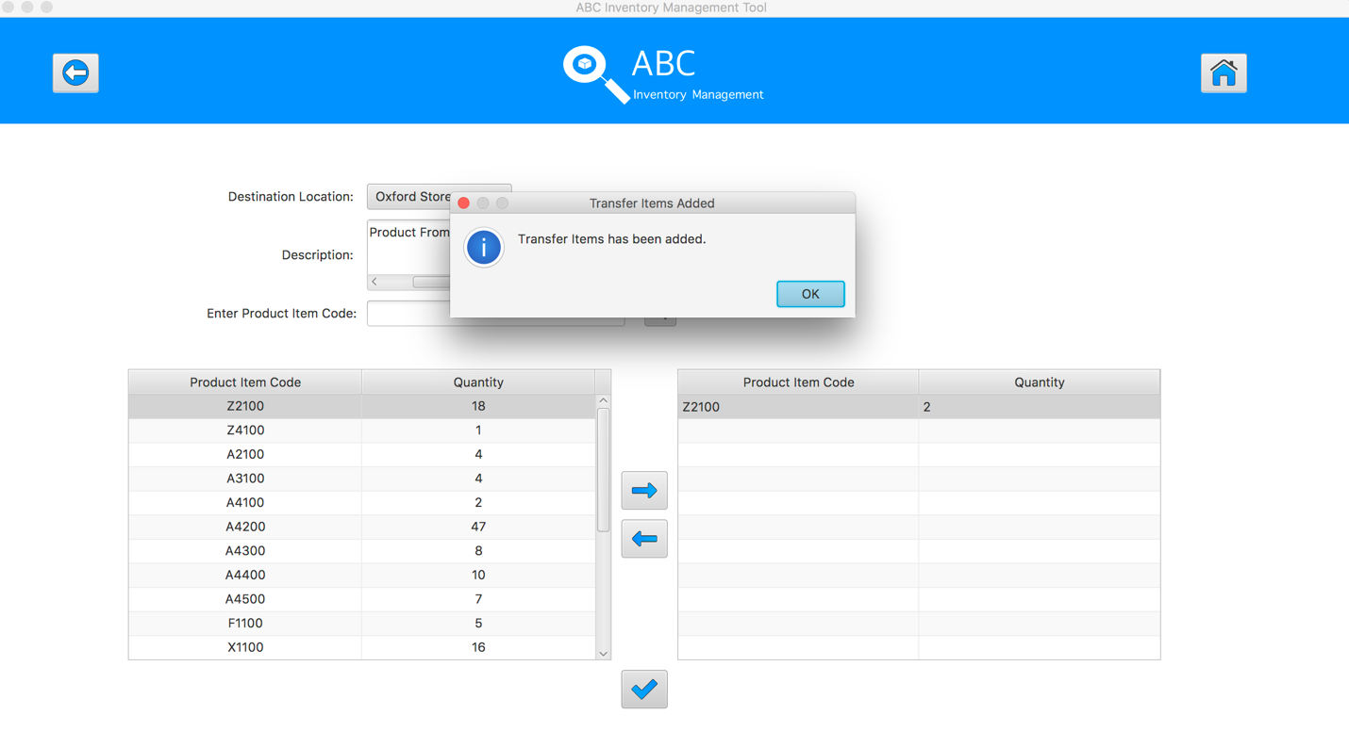

**Step 12**

Reset the interface for working with new transfer.

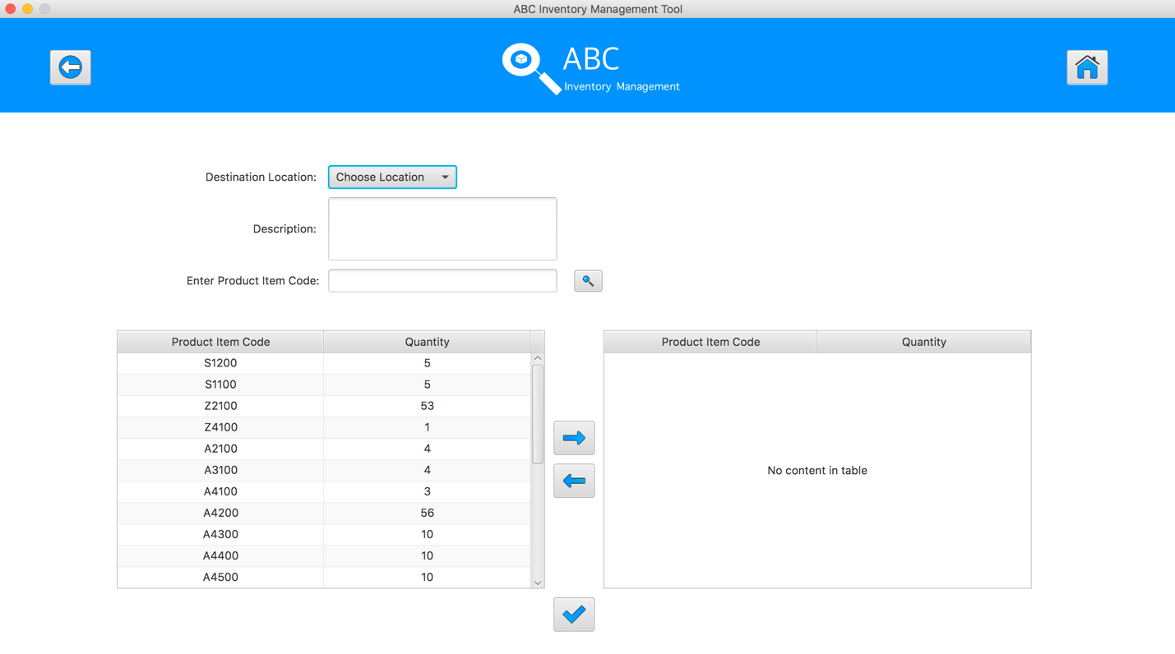

## Data Set 2

|  |  |  |  |
| --- | --- | --- | --- |
| **Test Data Table** | | | |
| **Destination Location** | Epping Store | | |
| **Description** | Send Product From Warehouse to Epping Store | | |
| **Product Item Code** | A4500 | A4500 | A4200 |
| **Quantity** | 2 | N/A | 6 |

# Result Screenshots

The screenshots of the result on each test step for each data set are given below:

**Step 1**

Select the destination location



**Step 2**

Enter the description for this transfer

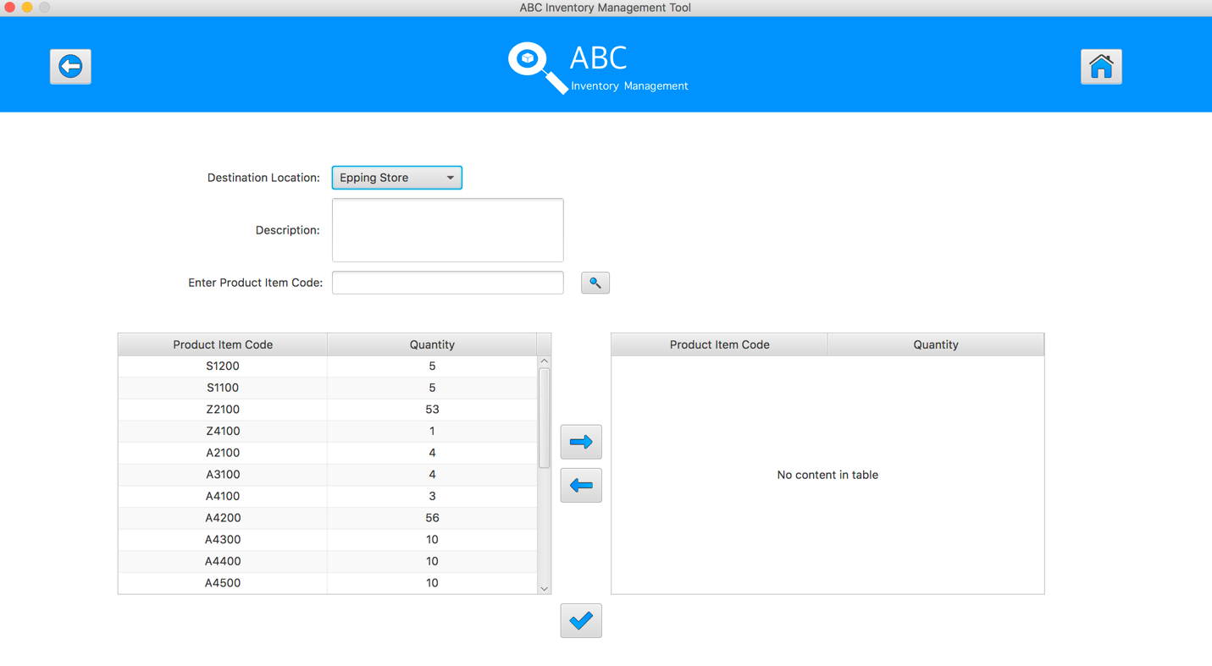

**Step 3**

Select the product item code in the table on the left

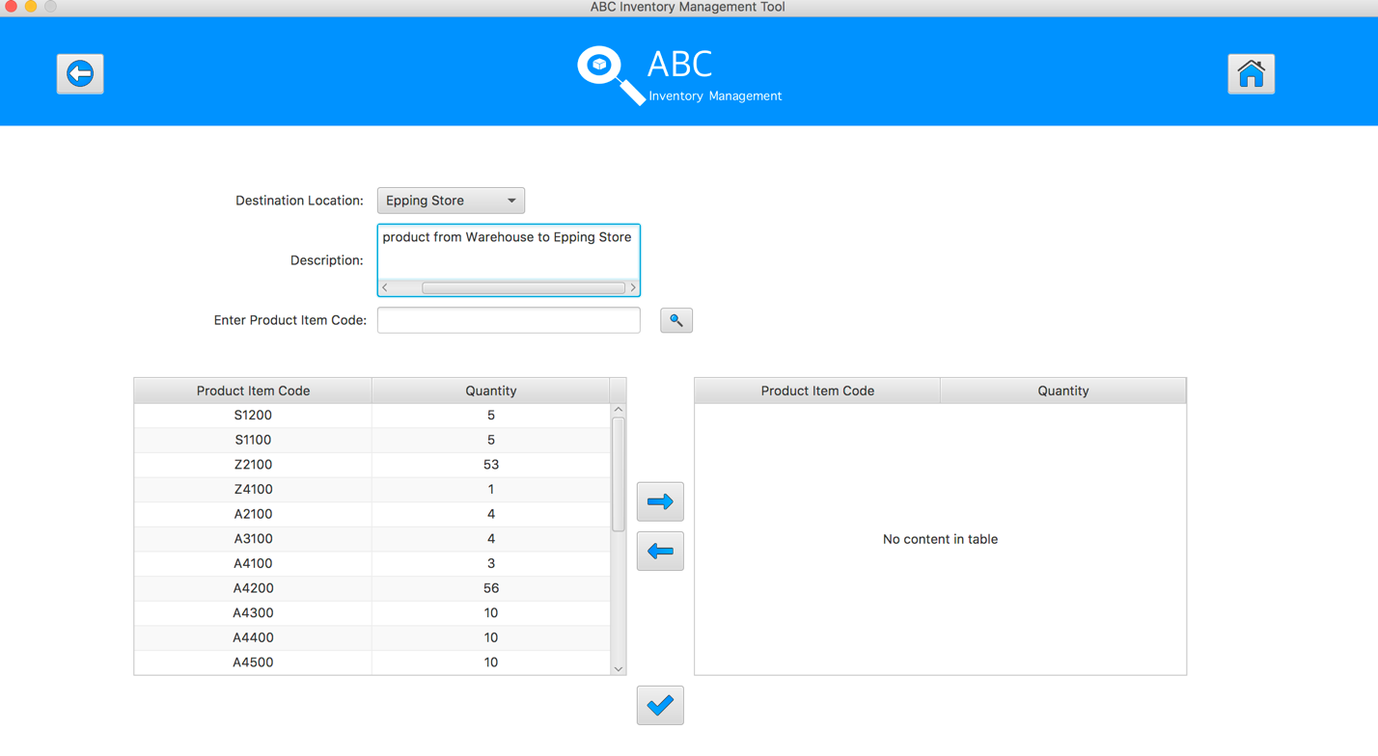

**Step 4**

Select the product item code in the table on the left

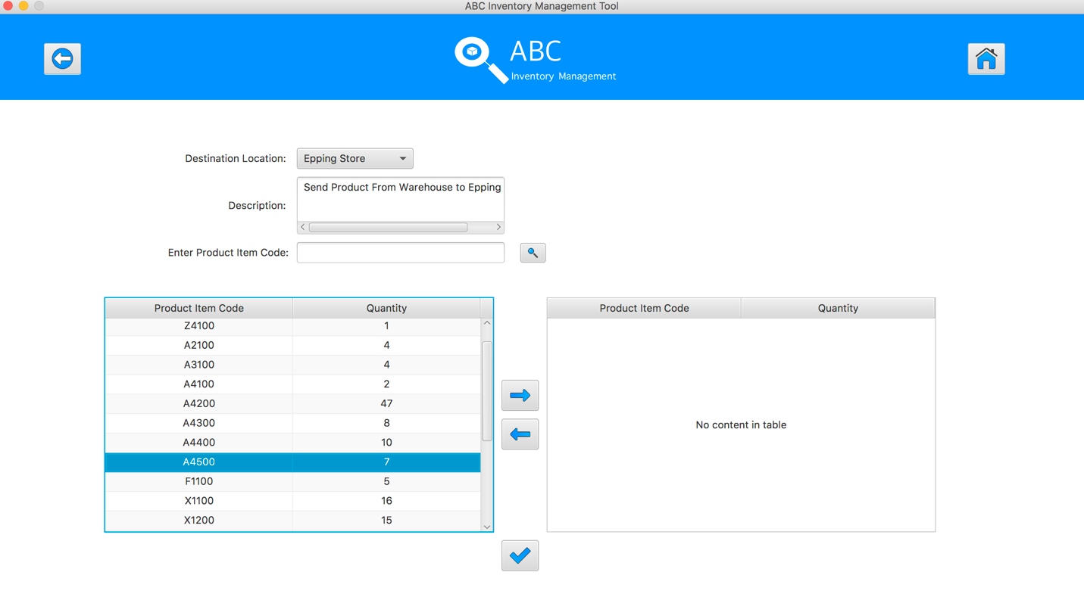

**Step 5**

Click on the “Add To Cart” Button

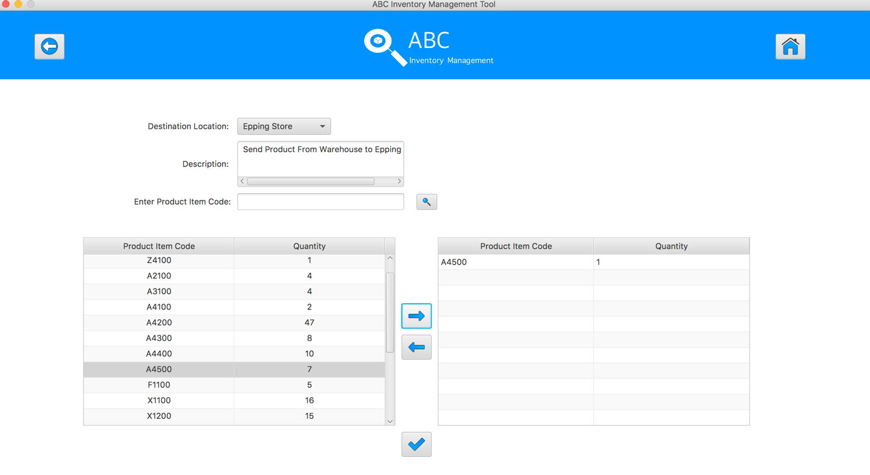

**Step 6**

Double click to the quantity cell in selected cart table

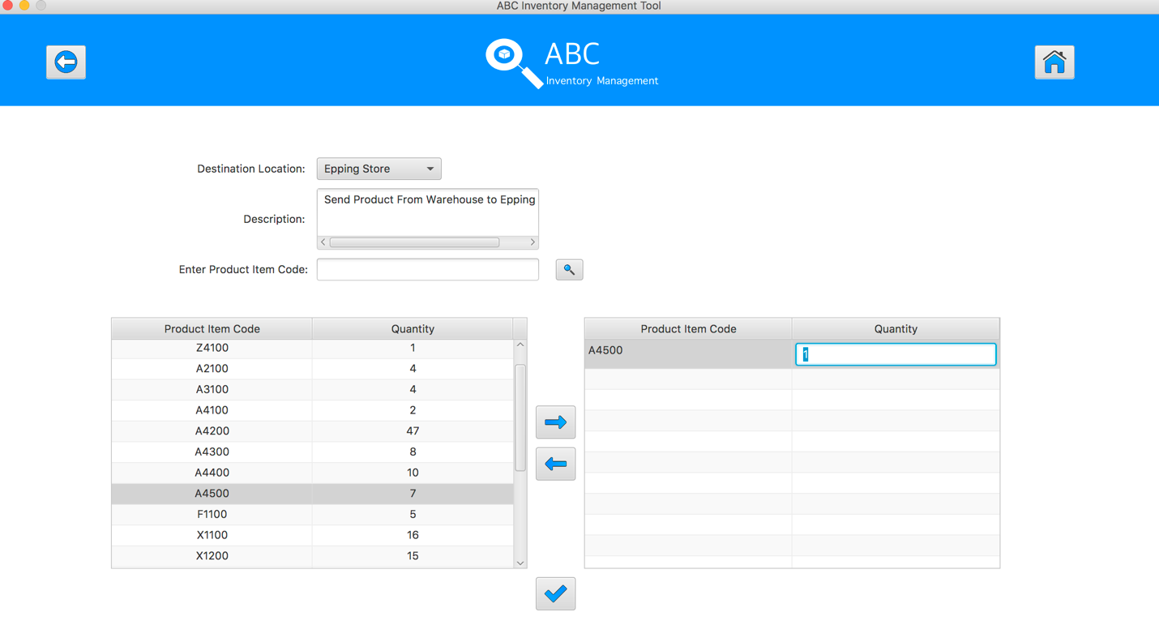

**Step 7**

Enter the desirable number

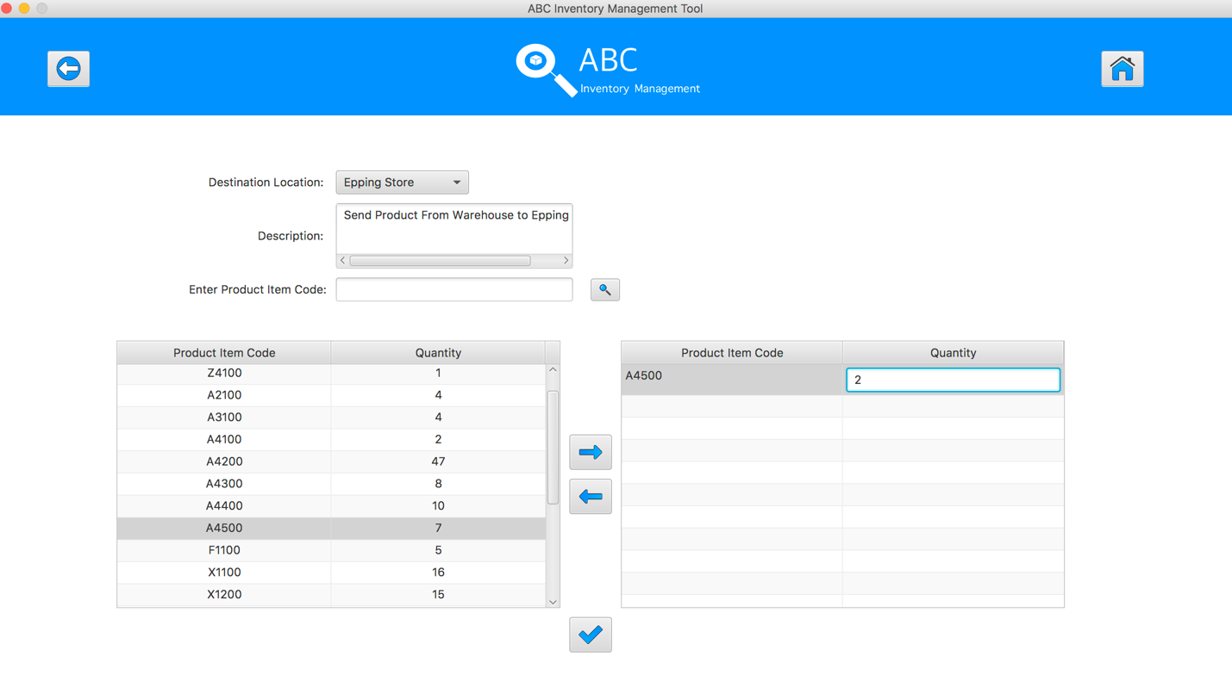

**Step 8**

Hit enter key to confirm this edited quantity

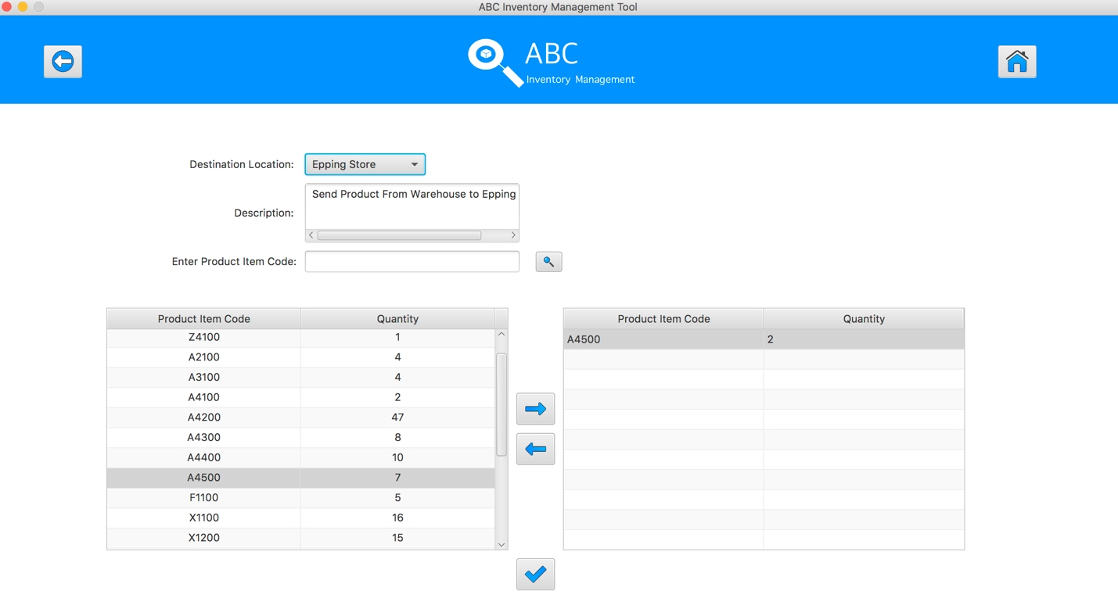

**Step 9**

Select the same product item code which was added to cart table in the table on the left

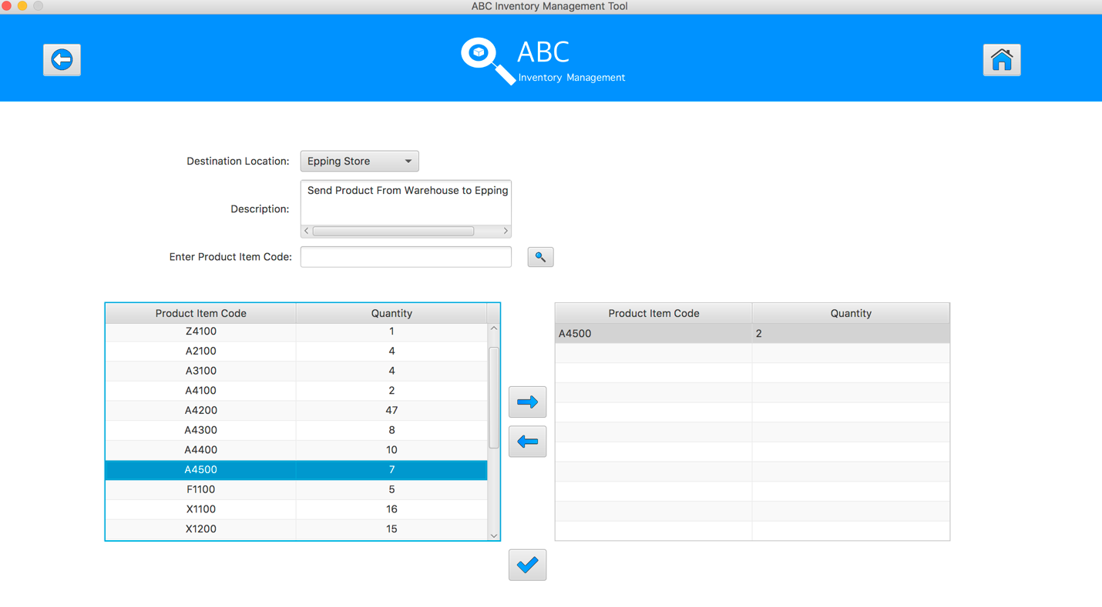

**Step 10**

System displays an alert message to notify that user cannot add this product to the cart again.

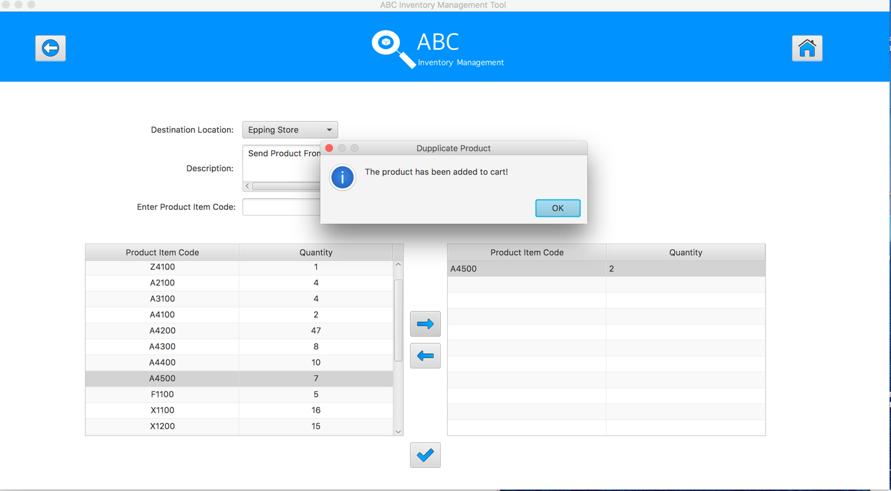

**Step 11**

Select the product item code in the table on the left

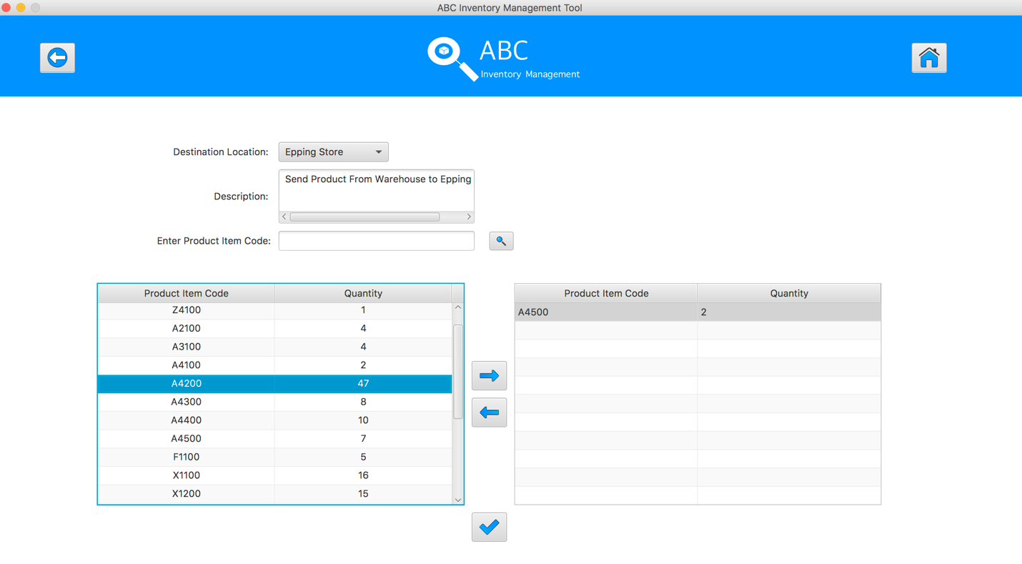

**Step 12**

Click on the “Add To Cart” Button

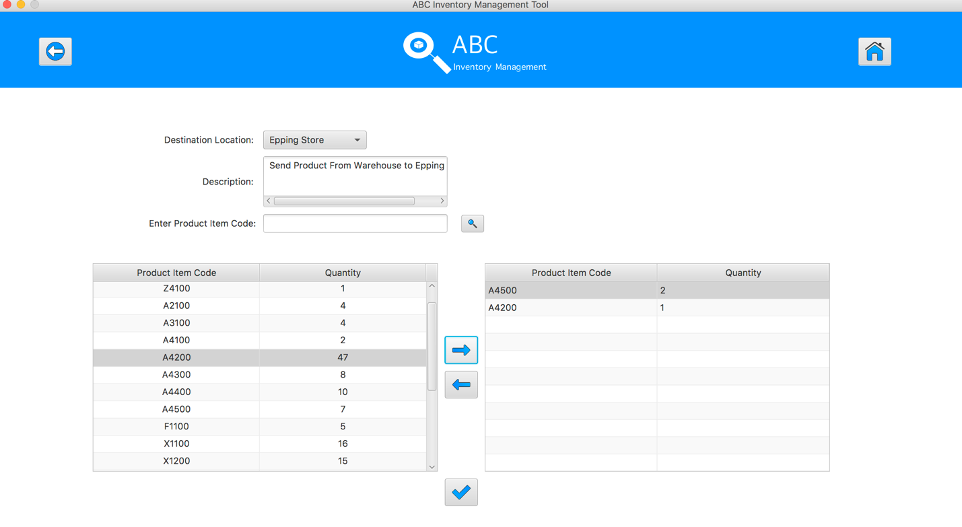

**Step 13**

Double click to the quantity cell in selected cart table

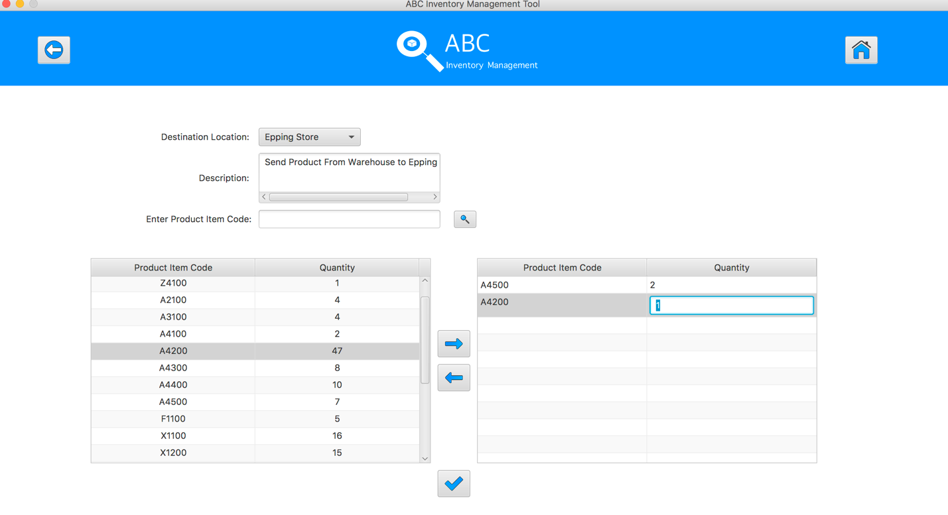

**Step 14**

Enter the desirable number

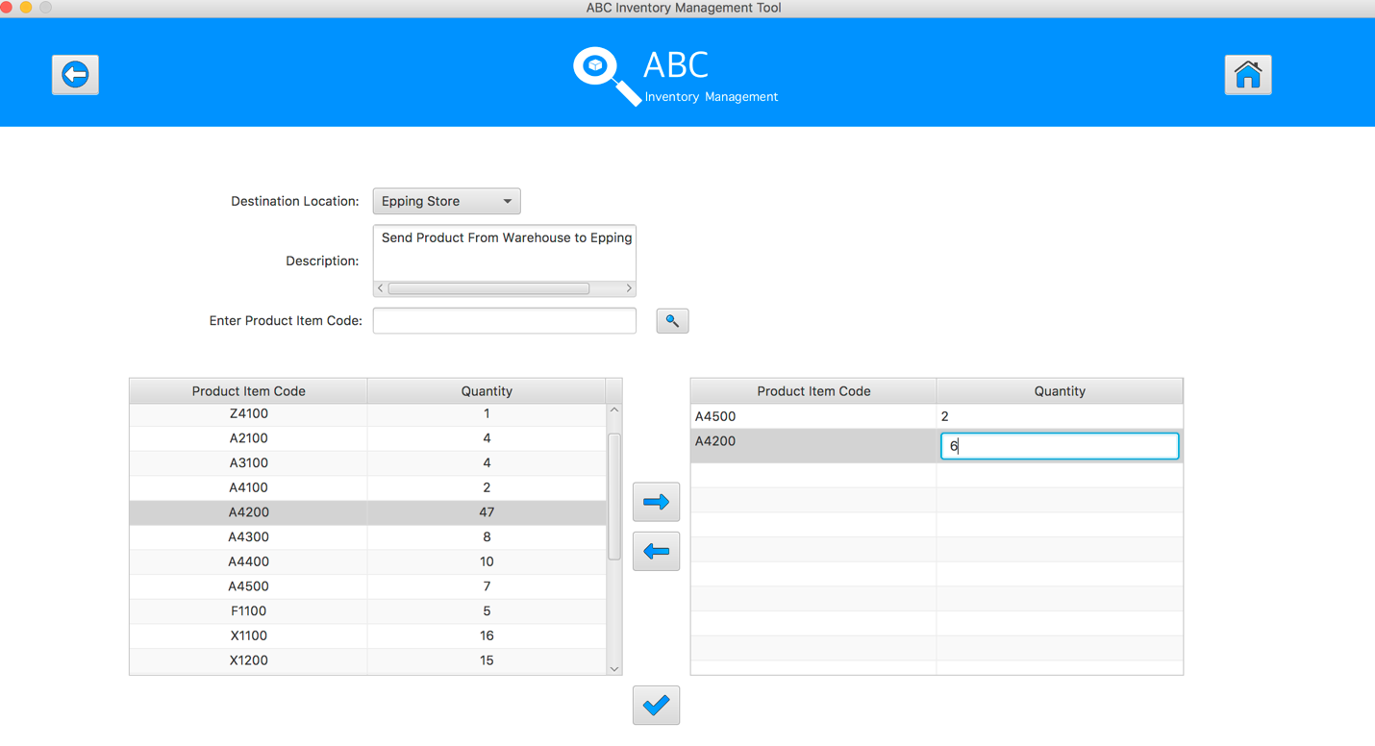

**Step 15**

Hit enter key to confirm this edited quantity

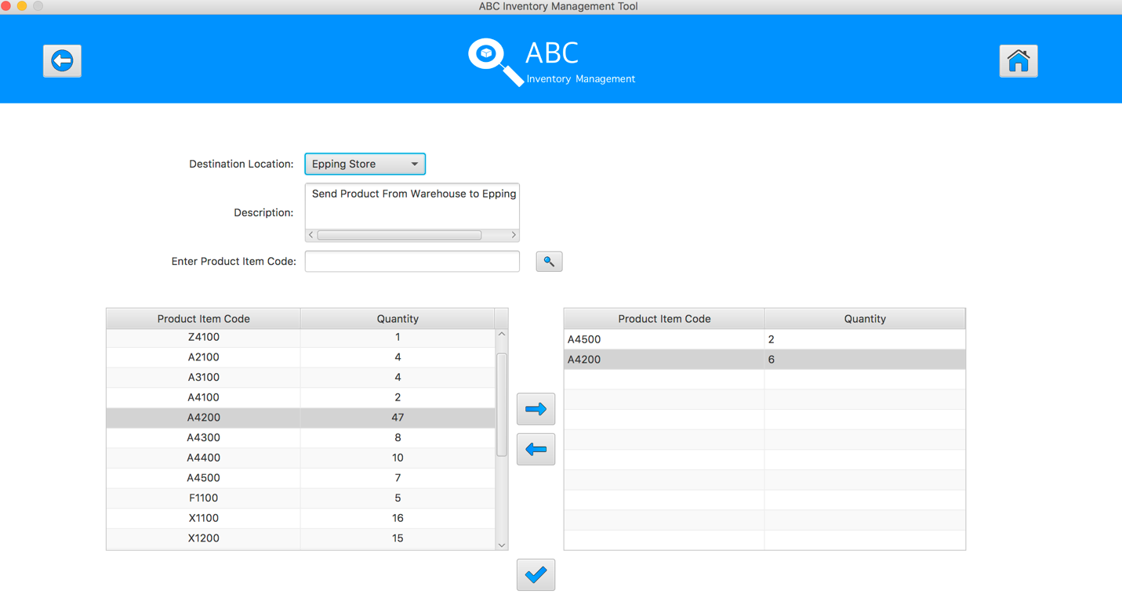

**Step 16**

After added the desirable items, hit the “Send Product” Button 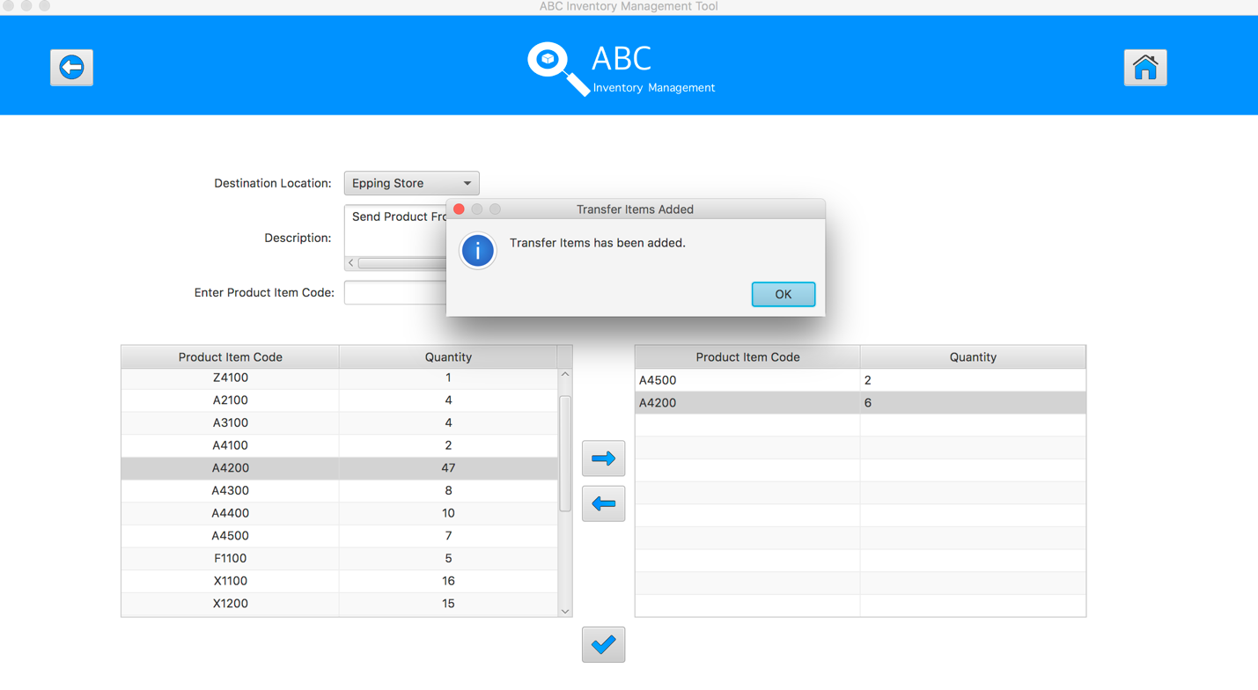

**Step 17**

Reset the interface for working with new transfer.

